

**SCHOOL OF COMPUTER SCIENCE ENGINEERING**

**AND INFORMATION SYSTEMS**

**FALL SEMESTER 2024-2025**

**PMCA506L – CLOUD COMPUTING**

**DIGITAL ASSIGNMENT**

**SUBMITTED ON: 11 – SEP - 2024**

**SUBMITTED BY-**

**AKASH KUMAR BANIK**

**PROGRAM: MCA**

**REGISTER No.: 24MCA0242**

**DEPLOY AN APPLICATION OF YOUR CHOICE, DEVELOPED IN ANY LANGUAGE, ONTO A CLOUD PLATFORM.**

**CLOUD SERVICE USED: MICROSOFT AZURE**



Microsoft Azure is an expansive cloud computing platform created by Microsoft, designed to meet the diverse needs of modern businesses and developers. It offers an extensive array of cloud services that span computing, analytics, storage, and networking. This broad spectrum of services allows users to select and tailor the resources they need to fit their unique requirements. One of Azure's key strengths is its support for a variety of programming languages, frameworks, and operating systems. Whether you're working with .NET, Java, PHP, Python, or Node.js, Azure provides the tools and environments needed to build and run applications efficiently. It offers both Infrastructure as a Service (IaaS) and Platform as a Service (PaaS) solutions, giving businesses the flexibility to choose the level of control and management they prefer. This flexibility extends to the ability to build, deploy, and manage applications using Azure's vast global network of data centers. This network ensures that applications can be scaled seamlessly and securely, providing high availability and performance regardless of where users are located. With Azure, businesses can leverage powerful cloud resources to create scalable, reliable, and secure solutions that address a wide range of needs and use cases.

**LINK TO THE LIVE DEMO OF MY WEB PAGE ON AZURE:**

<https://red-bush-0be51e210.5.azurestaticapps.net>

**DETAILED STEPS TO DEPLOY A WEB PAGE ON AZURE USING AZURE STATIC WEB APPS**

1. **Created a GitHub Repository:**

* First, I logged into GitHub with my account.
* I clicked on the “+” icon in the upper right corner and selected “New repository”.

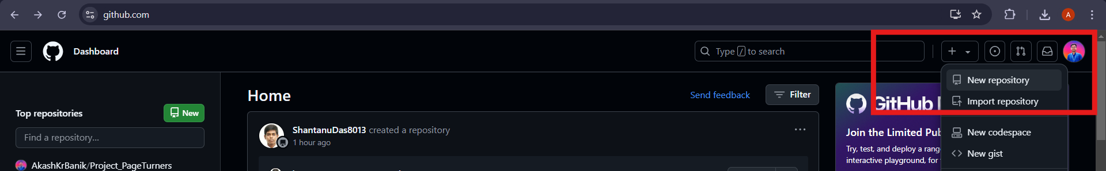

* I named my repository as “Project_PageTurners” and optionally added a brief description. I chose to keep it public for this project.

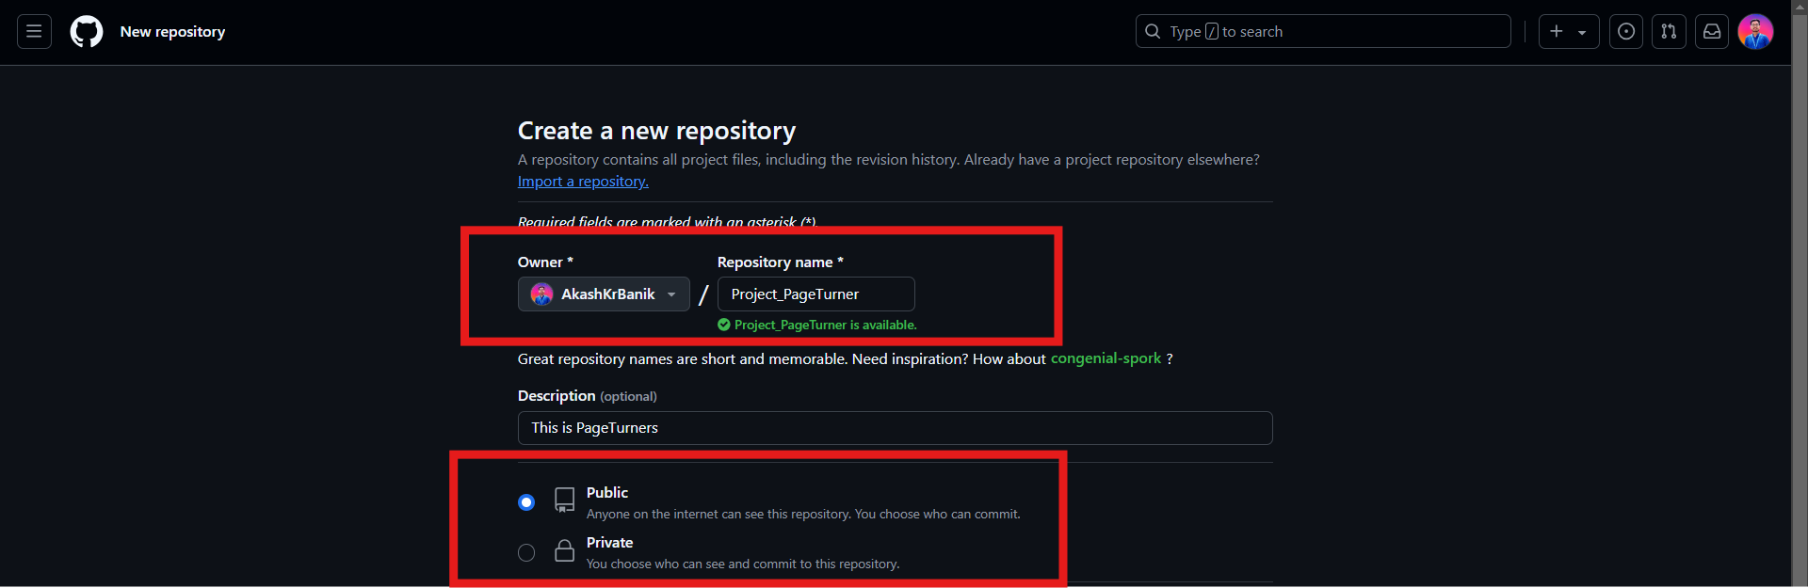

* After filling in these details, I clicked “Create repository”.



1. **Uploaded My Web Page to GitHub:**

* Next, I cloned the repository to my local machine by running the following command in my terminal:

git clone <https://github.com/AkashKrBanik/Project_PageTurners.git>

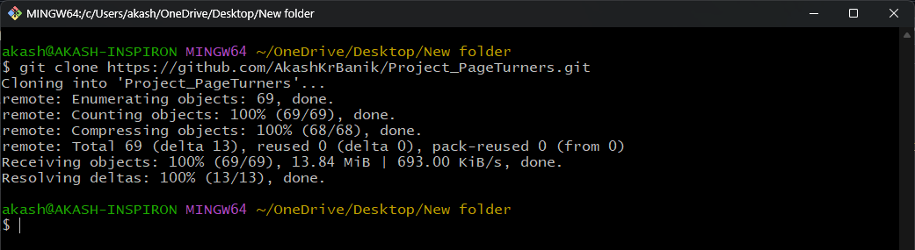

* I navigated into the repository directory and then added my webpage files, including ‘index.html’, ‘styles.css’, and ‘scripts.js’, to this directory.
* After that, I staged, committed, and pushed these changes to GitHub using the commands:

git add .

git commit -m "Initial commit of web page"

git push origin main

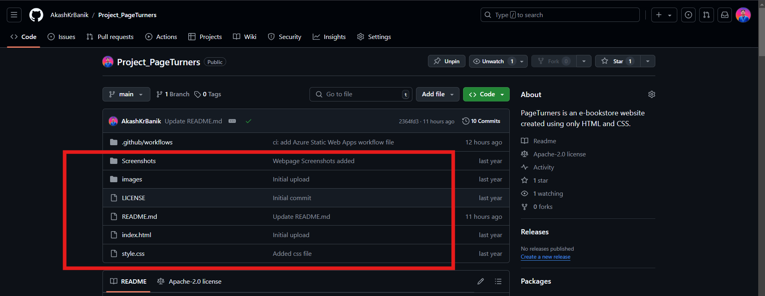

1. **Created a Microsoft Azure Account:**

* I started by visiting the Microsoft Azure Portal (<https://portal.azure.com/>) and signed in with my Microsoft account.
* As a student, I applied for the Azure for Students offer, which provides free credits and access to essential cloud services. To do this, I visited the Azure for Students page.
* I clicked “Take Free” and was prompted to sign in with my Microsoft account.

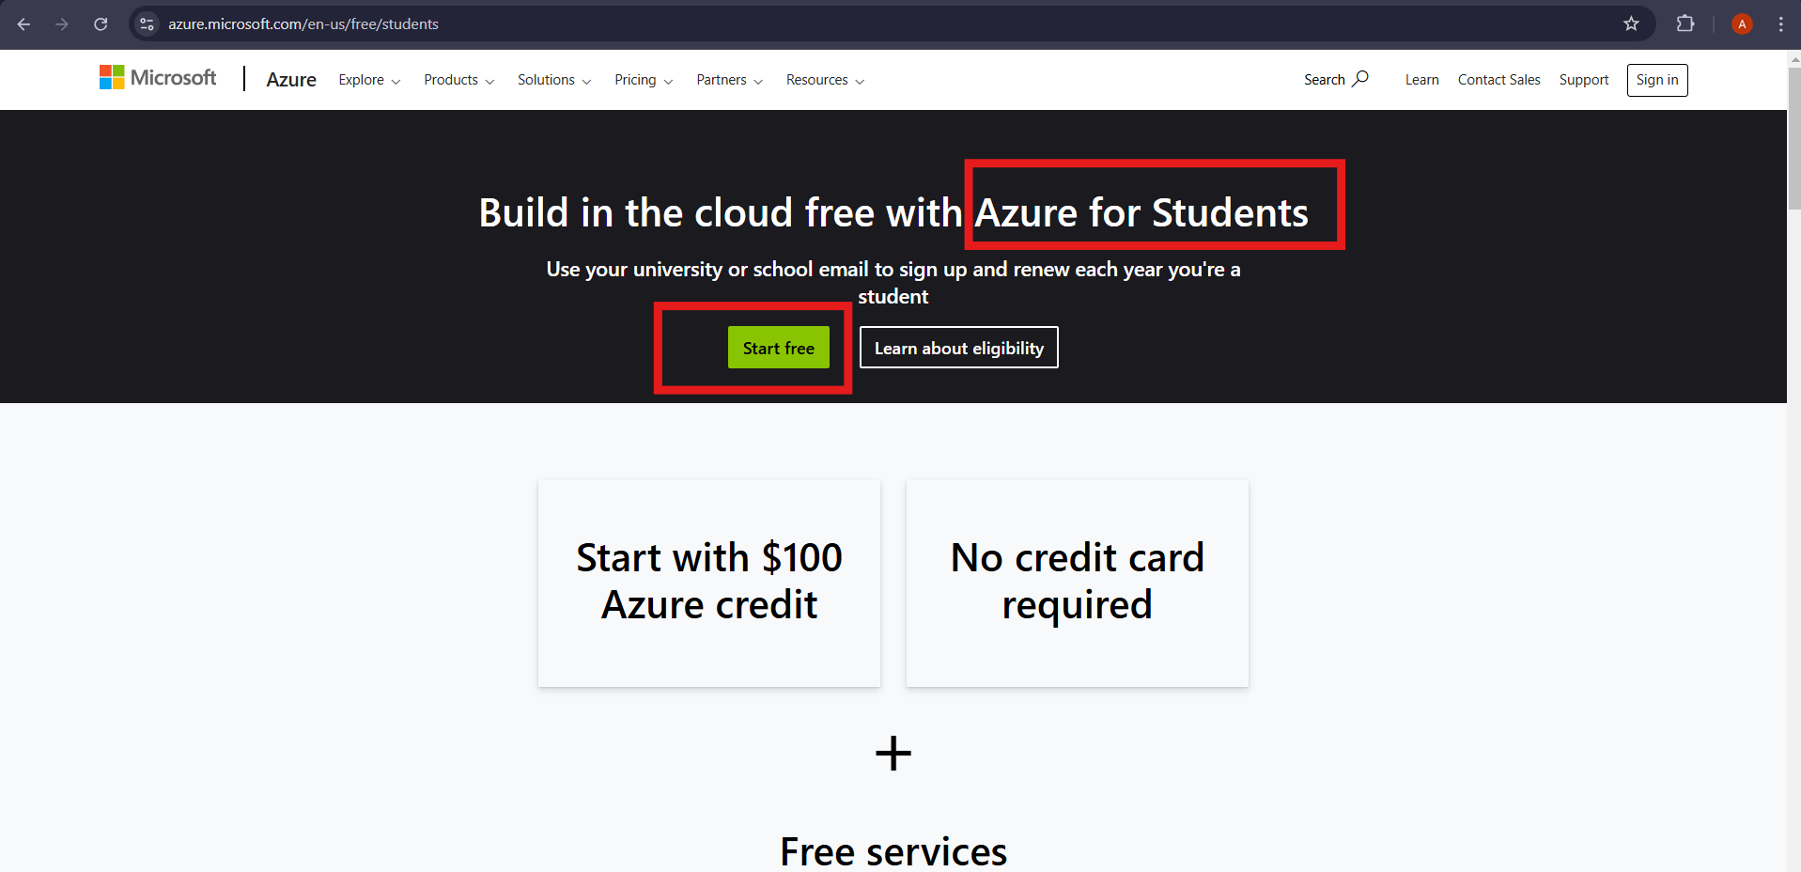

* After signing in, I filled out my information, including verifying my academic status using my university email.
* Once my student status was confirmed, I was granted $100 in free credits and access to services such as Azure Static Web Apps, which I used to deploy my project.

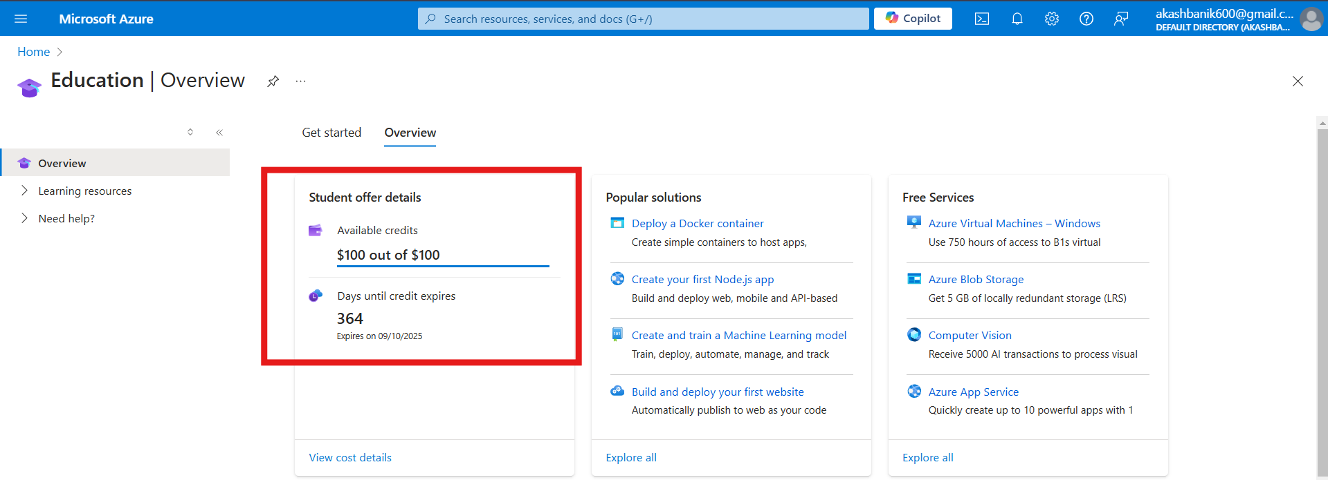

1. **Set Up a New Static Web App on Azure:**

* In the Azure Portal, I clicked on “Create a resource” from the menu on the left.
* I searched for “Static Web Apps” and selected it from the search results.

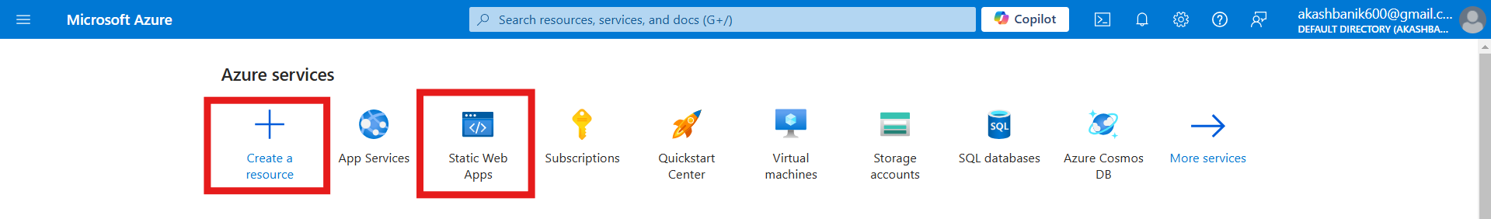

* I clicked “Create” to start setting up my new Static Web App.

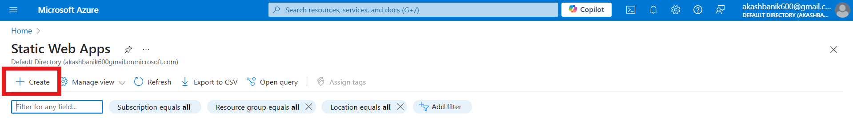

1. **Configured Basic Settings:**

* I selected my Azure subscription and created a new resource group named “PageTurner_ResourceGroup” for my project.
* I entered a unique name for my web app (PageTurners) and picked the region (India) where I wanted it to be hosted.
* Next in the “Deployment Source” section, I selected “GitHub” as I was deploying from My GitHub account.

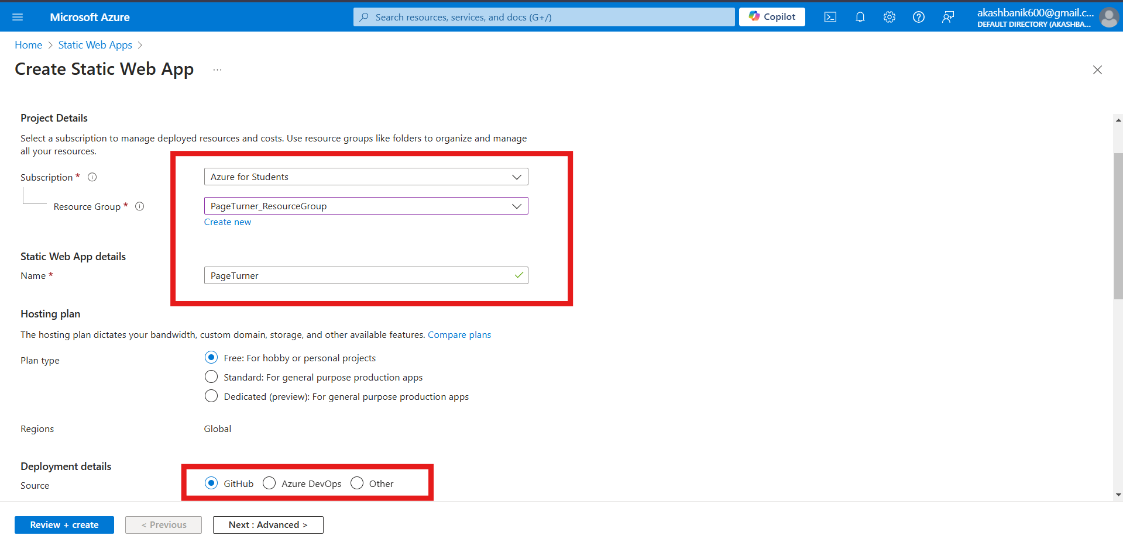

1. **Authenticated and Connected to GitHub:**

* I clicked “Sign in with GitHub” to connect my GitHub account with Azure.
* After authorizing Azure to access my GitHub repositories, I chose my repository “Project_PageTurners” which is to be deployed.
* I configured the build settings, including specifying the branch (`main`) for deployment.

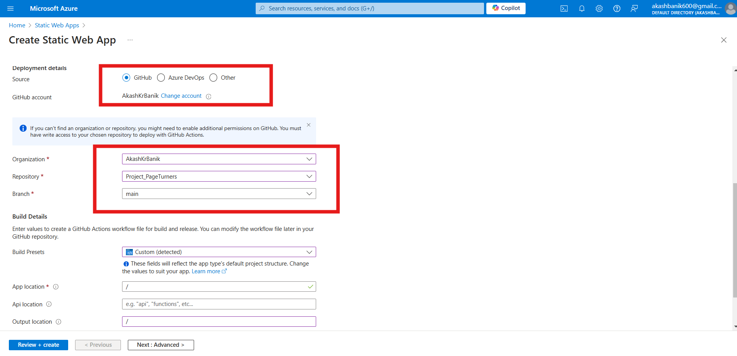

1. **Reviewed and Created the App:**

* Here, I reviewed all the settings to ensure they were everything was correct.
* I clicked “Create” to start the deployment process and as soon as I clicked, Azure set up the infrastructure and created a GitHub Actions workflow to handle future deployments from my repository.

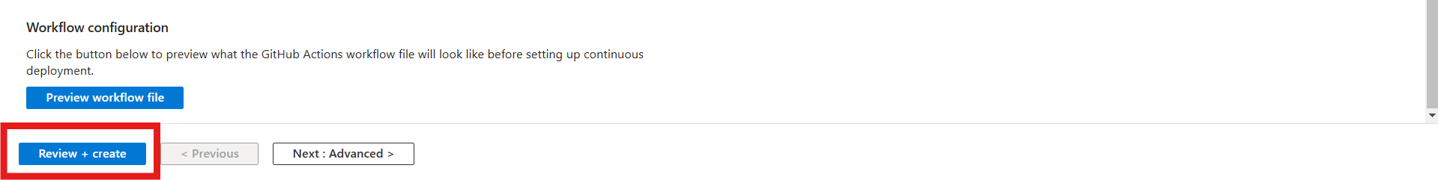

1. **Monitored the Deployment:**

* I monitored the deployment progress in the “Deployment Center” of my Web App in the Azure Portal.
* Once deployment was complete, I received a default domain URL where my web page was now live.

1. **Accessed My Deployed Web Page:**

* I navigated to the “Overview” section of my Static Web App in the Azure Portal.
* I found the “Default Domain” URL and clicked on it to view my live web page in the web browser.

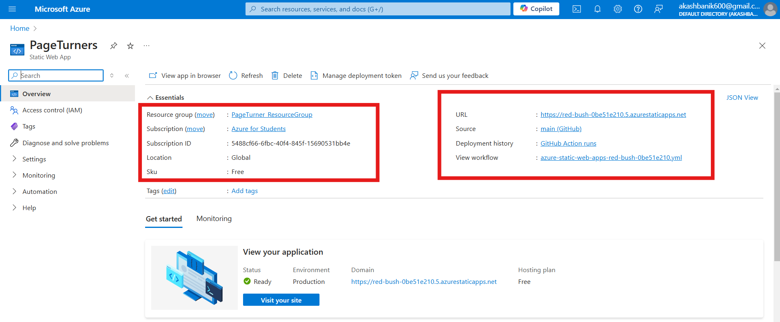

**Website Screenshots:**

